**Water Table 2–Replenishing more water than we consume**

Since year one, we have contracted 49 replenishment programs in water-stressed basins, which are expected to deliver more than 61 million meters cubed of replenishment volume over their lifetime.

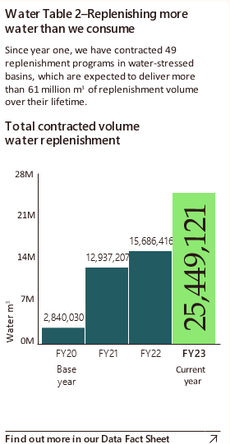

Bar graph showing Total contracted volume water replenishment from FY20 to FY23, with FY20 as the base year and FY23 as the current year. It shows a gradual increase in contracted volume water replenishment from 2,840,0301 cubic meters in FY20 to 25,449,121 cubic meters in FY23.